Permission System Evaluation on the Android Mobile Platform
Luke McLeese, Jacen Watkins, James Cole
Mentors: Xiaoyong Zhou and Zheng Dong

School of Informatics and Computing, Indiana University
INFO-I399 Security Group #1

Abstract. Over the past few years, smartphones have become increasingly ubiquitous in the daily life of people everywhere. With this, smartphone users are using their mobile devices to store and handle a significant amount of personal information on a daily basis. In order to maximize the potential of their smartphones, users turn to smartphone applications that range in function from business and finance to games and shopping. However, recent studies and data reveal that a user’s personal information is compromised at the hands of rogue smartphone applications. One of the fastest growing mobile platforms, the Google powered Android, has become a playground for malware creators. The current Android security architecture, market, and security options fail to protect the mobile user’s personal information from landing in the hands of malicious developers. In this paper, we discuss our group’s evaluation of the current Android security features, in particular, the current Android permission system. Our objective was to evaluate the current Android phone system and Marketplace, and improve security for Android users. To do this, we surveyed the permissions of one hundred and fifty benign applications and fifty-six malicious applications off of the Android Marketplace, developed a database of this survey, and compiled statistics and statistical analysis. Using Matlab software, we were able to use our data to create a decision tree classifier that accurately classified a malicious application 96.4 percent of the time. With the survey expanded and the classifier implemented into an Android application, we believe that an Android user’s personal information can become increasingly more secure.

Introduction
Mobile phones are becoming increasingly ubiquitous in today’s society. According to a recent report from Gartner, Inc., worldwide mobile device sales to end users totaled 1.6 billion units in 2010, an increase of 31.8 percent from 2009 [2]. Smartphones, mobile phones that offer more advanced computing ability and connectivity than a feature phone, saw a 72.1 percent increase compared to sales in 2009 accounting for 20 percent of total mobile phones [2]. This number continues to grow as the sophistication, features, and convenience of smartphones continues to progress. According to a recent Nielsen survey, 36 percent of US mobile consumers now have smartphones. In addition, smartphones recently made news, partly due to the Verizon iPhone, by making the US mobile market a smartphone majority, accounting for 54 percent of sales in the first quarter of 2011 [11]. In addition, the wide availability of “feature-rich applications” available on the Apple App Store, Android Marketplace, and Blackberry App World has made smartphones a hot commodity [10]. Given the increased sophistication of today’s smartphones, users are increasingly relying on them to store, handle, and secure personal information. For example, we can find an individual’s call log, contact list, email address, location, URL history, and even stored passwords on their mobile smartphone devices. With all this information being private, there is growing concern regarding the safety of personal information being stored on smartphones. Unfortunately, recent studies reveal that there are malicious applications that can be uploaded onto app stores and then successfully advertised to users [10, 4, 8, 13]. These malicious applications are accessing a user’s personal information, storing it, and then most of the time selling it to different advertisement and marketing firms. In addition, a recent study involving TaintDroid revealed that popular applications were sending user data to advertisers, without user consent.

The Android operating system, a popular open source system that allows developers to upload applications directly onto the Marketplace for a $25 dollar fee, has become increasingly vulnerable to malware. Currently, Google is not doing enough to ensure that an Android user’s personal information, which is stored on the mobile device, is secure from malicious developers and applications. In this paper, we evaluate the current Android security system and create a classifier that could be implemented into an Android application in order to help Android mobile user’s prevent malicious applications from being downloaded onto their mobile device.

Statement of Research Problem
The current Android operating system is becoming increasingly more popular and will be the leading smartphone mobile platform by the end of 2011. However, the current Android security architecture and operating system is not providing adequate security for Android mobile phone users, which will become increasingly more problematic as popularity continues to rise.

Background
The Android operating system for smartphones is an open source platform backed by Google that was released in 2008. The Android operating system has seen a rapid increase in popularity since the release of the first phone to use Android, the HTC Dream, branded by T-Mobile as the G1. One of the most popular operating systems is the Android mobile platform. Android sales accounted for 22.7 percent of the 2010 market share, up from only 3.9 percent in 2009 [2]. The Android operating system moved to the No.2 position in the smartphone operating system market with an 888.8 percent growth in 2010. In the fourth quarter of 2010, Android accounted for 33 percent of the global market share, making it the No.1 purchased mobile platform in the world [2].
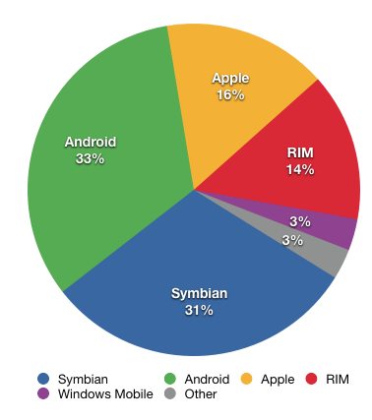
According to a recent report from Gartner, Inc., Android sales controlled 33 percent of the smartphone market share in the 4th quarter of 2010. For the first time, Android assumed control of the No. 1 spot from the Nokia Symbian operating system. [2]
The Android operating system will continue its rise in popularity. According to the International Data Corporation (IDC), the Android operating system will account for 39.5 percent of total smartphone sales in 2011 [14]. According to the firm, the smartphone market will grow 49.2 percent overall in 2011, shipping out over 450 million units compared to 303.4 million units in 2010 [14]. By 2015, IDC predicts that the Android will control 45.4 percent of the market share, almost half of overall smartphone sales. The table below shows the global phone market for 2011 and 2015 [14].

The rise in smartphone popularity is mostly due to the increased sophistication of the operating system and the wide range of available applications. Applications can be installed on Android devices through the Android Market and other untrusted third party sites. The Android Market contains both vendor provided programs and third party applications. These third party applications have become increasingly more apparent on the Android Market in the past few years. For example, the Android Market had an increase from about 15,000 third party applications in November 2009 to about 150,000 in November 2010 [10]. There are now over 200,000 applications available on the Android Market that were created by third party developers [10]. According to a recent report by The Nielsen Company, Android and iPhone users account for 75 percent of all mobile app downloaders [11]. According to this report, Android users, on average, have thirty-five applications installed on their mobile devices. Sixty percent of these users reported using these applications multiple times a day [11]. The more useful and helpful smartphones and smartphone applications become, the more personal information is stored on user’s mobile devices.
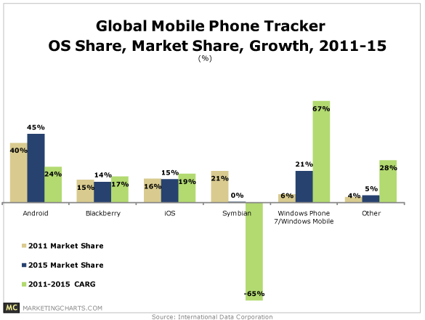
This chart shows the growth of Android cell phone market share compared to other popular operating systems.

According to a recent survey of U.S. consumers on smartphone security, the Ponemon Institute found that 84 percent of those surveyed use the same smartphone for both business and personal use. The crossover between personal usage and business purposes means that more sensitive and confidential data will be stored on the phone, and is therefore at risk. Also, the survey found that 66 percent of smartphone users admit to keeping a moderate or significant amount of personal data and information on their smartphones. This includes email addresses, contact lists, videos, photos, name, personal dates, Internet history, etc. In addition, this survey indicated that only 42 percent of smartphone users worry that a hacker will attack their smartphone and only 43 percent feel like security is an important feature on their smartphone [16].

In reality, security is a huge concern for smartphone users, in particular Android users. According to the Kapersky Lab, the Android operating system is now at risk to over seventy different types of malware, up from just two at this time last September [15]. Recently, Google made news by pulling fifty-six malicious applications off of the Android Market [12]. These applications used a type of malware referred to as “DroidDream.” DroidDream uses copies of legitimate applications posted on the Android Market to package their malware and distribute it to unsuspecting users. “Unlike previous instances of malware in the wild that were only available in geographically target alternative app markets, DroidDream was available in the official Android market, indicating a growing need for mainstream consumers to be aware of the apps they download and to actively protect their smartphones” [13]. The infected applications were available on the Android Market for four days, and were downloaded to as many as 200,000 Android mobile devices. While some of the applications had names that should beg for scrutiny, such as Super Sex Positions, Hot Sexy Videos, Hilton Sex Sound, others seemed innocent to users, with the names of Photo Editors, Super Stopwatch, and Chess. All fifty-six applications were uploaded from three malicious developers, Kingmall2010, we20090202, and Myournet [13]. Unlike Apple, which screens an application and looks through its code before uploading it onto the App Store, Google allows developers to upload applications directly onto its Android Market with only a developer signature and a $25 dollar fee.

In addition, Android applications are sharing user data without user notification. A recent study called TaintDroid revealed that among thirty popular Android applications, there were sixty-eight instances of possible misuse of users’ private information [10]. TaintDroid followed the path of information, an often times figured out that information was being sent out to secret nodes and servers. A curious team of researchers from Intel Labs, Penn State, and Duke University, recently used a TaintDroid extension in order to log and monitor the actions of thirty Android applications. These thirty were picked from the 358 most popular. The researchers found that fifteen out of the thirty applications shared location information and/or other unique identifiers with advertisers. These fifteen applications shared this data with advertisers without informing users that data was being shared and some of these applications even sent out data while the applications were not in use [10].

With the increase of popularity, the Android operating system is continually fighting off malicious attacks. With an open market, developers can easily package malware inside applications and upload them directly onto the Android Market for unsuspecting users to download. The current Android security system has multiple flaws and Android users need new ways to protect their private personal data from a malicious attack. In addition, Google explains their permission restrictions with only one sentence long explanations that often times are not adequate in informing the user of what data they are giving the applications permission to use. Furthermore, in order for an Android user to run an application, he or she must agree to all of the permissions at the time of installation and cannot re-adjust the permissions or constraints dynamically. Android security hinges on the mobile phone user, and in order to secure their mobile devices, Android users need more specific permissions, explanations, and security tools to protect applications from stealing their personal information.

The rest of this paper explains the current security architecture of the Android operating system, related work, our research methodologies, our research results, data, analysis, and conclusions including recommendations for future work.

Current Android Security Architecture
As mentioned before, Androids as well as other smartphone platforms, are used for both personal and business purposes. This makes it that much more enticing for malware developers that are trying to get their hands on any sensitive information that they think can net them more money. Because of the exponential growth of the Android platform in the past few years, Android has become a target for malware developers worldwide. These malware attacks can cripple the individual Android smartphones by making them unusable in some cases or leaking personal information to the malware developers. Over the course of a year the number of different types of malware developed for the Android platform has grown from two to over seventy unique types, and this number just keeps growing. Some predict that the number of malware types will continue to grow and that it could possibly increase fivefold by 2013 (17). In order to prevent the spread of the malware, the Android platform separates all of the individual parts of the operating system into what are called permissions. The individual permissions must be displayed by the developer so that the individual user can know exactly what the application is going to have access to on their phone.

One of the main components of the Android’s current security setup is that no application, by default, is able to perform any actions that could cause harm to the individual users, the Android operating system itself, or any other Android applications that may be on the same Android device. [1]

The current Android security architecture consists of:
A privilege-separated operating system, with each application having their own distinct system identity, containing both a Linux user ID and a group ID. This allows Linux to isolate applications from each other and from the operating system. [1]

What this does, is it allows the Android operating system to separate out the individual applications by giving them each their own personal identifier. This allows the operating system to recognize that the applications are not exactly a part of the operating system but something separate. It also separates out the individual applications from each other by creating a separate process for each application; this creates a sandbox so that two applications with different IDs can’t occupy the same space on the process list. Because applications are separated in this way, they are also not allowed to share information about the user with other applications unless they have the same ID.

All applications must declare permissions that they require to run, and the Android system prompts the user for consent before the application is installed. These permissions enforce restrictions on the operations that a particular application can perform. [1]

This is one of the most crucial parts of the current Android system. The permissions are the support for the entire Android security system. What they do is effectively restrict any application to a list of given permissions. “There are about a 100 built-in permissions in Android which control operations including: dialing the phone (CALL_PHONE), taking pictures (CAMERA), using the Internet (INTERNET), listening to key strokes (READ_INPUT_STATE) or writing an SMS (WRITE_SMS)” (17). The developer can then choose which of these permissions are necessary for their application to operate effectively and at the time of download the user is also given this same list of all the permissions that are used in the specific application that they are downloading. The user has to agree to all of the permissions in order to install and run the application. This does a few things; it keeps the user more aware of what exactly they are downloading and how it will affect their Android device after it is downloaded. This permissions system also keeps the developers accountable for what they are allowing their application to do on the user’s device.

Android has no mechanism for granting permissions dynamically. [1]

This is one of the simplest ideas given here but it is still very important. What this does is that it prevents an application from changing the permissions that it uses after it has been downloaded. This makes sure that the user is protected from developers that would hope to develop a benign application and get a large install base before they slip in malicious code and a new set of permissions that would take advantage of the users. In addition, this is somewhat problematic because a user cannot change the permissions granted for that application dynamically.

All Android applications must be signed by their developer, enabling Google to identify the author of the application. [1]

This is another relatively straightforward facet of the current Android framework. This is another form of accountability for the developer. Google requires this in the hopes that they can identify and track down anyone that develops malicious content.

Another aspect of Android security is in its file access. The way that Google set this up is that even if an application has permission to write files, they will not have access to a certain set of crucial files. The way that they accomplished this was by setting up these crucial files to be read-only by putting them on the ramdisk, which is restarted with every reboot (17). Another aspect of the previously mentioned permissions is protection level. These protection levels are broken down into four separate groups: Normal, Dangerous, Signature, and SignatureOrSystem. Normal is what the majority of applications are set to and it poses little to no threat to the security of the Android platform. Dangerous requires a heads up from the developer letting the user know the dangers and requesting their permission in order to install. Signature is a level that pertains to applications that interact with each other; this is an uncommon protection level. The final protection level, SignatureOrSystem, is heavily discouraged and almost completely unused (17).

Even with this current security structure there are ways that they can be bypassed. The system that is in place is well thought out but is in no way immune to infection. The main focus of our study is on infection from a malicious application. We built a classifier to detect these applications from the permissions they use but we’ll talk more about that later in this paper. Infection through download is a common way for an Android phone to be attacked. This simply involves downloading an application that doesn’t do what it is advertised to do and instead runs malicious code on the smartphone which can cause the systems performance to decrease or halt altogether. Another issue that can come from these malicious applications is the theft of personal information that is stored on the phone. One of the other vulnerabilities that the Android platform has had in the past is with its web browser; attackers have been able to inject malicious code to the phone through the web by using the permissions that are available to the actual web browsing application. The final way that the Android platform is vulnerable is with its Bluetooth; this is the least likely of the three attack types that I’ve mentioned for a couple of reasons. For the device to be attacked through Bluetooth there would need to be another phone in the range of the device and the Android device must be set to discoverable and the user must download the content from the other Bluetooth device. This type of infection is definitely not very likely but is still in the realm of possibilities and shouldn’t be ignored.

Some people are saying that the rate at which the different types of Android malware are growing and changing has a lot to do with the PC market. Because there were so many people that had experience-developing malware for the PC, these same people were able to adapt their abilities and moved them over to the mobile platform at an alarming pace. Another area that is causing a proliferation of malware on the Android platform is the lack of user awareness. Most users don’t treat their phones as they would a regular computer and instead worry very little or not at all about what they allow their phone to access. While the permissions based system is effective on making users more aware of what an individual application may be doing to/with their phone, most people don’t take the time to look into the permissions and just click past them as soon as they are brought up just to speed up the process. In addition, Google provides vague explanations for what each permission actually entails. Sadly, even if the signs are right in front of the victims of the attacks, they may be in too big of a rush or inadequately educated in the field of Android security to prevent malware.

Related Work
Privacy issues on smartphones have recently attracted a lot of attention. Researchers have been trying to pinpoint malicious attacks, evaluate the current Android system, and offer new ways to fend off applications from stealing personal information and data. TaintDroid is one research effort that has targeted the Android platform. TaintDroid uses “dynamic taint analysis to track privacy data flow on Android” [10, 13, 4]. When the data leaves the system via a network interface, TaintDroid alerts the Android user with information about the taint source, the application that sent out the tainted data, and the destination. Articles related to TaintDroid included Taming Information-Stealing Smartphone Applications (on Android) [10] and TaintDroid: An Information-Flow Tracking System for Realtime Privacy Monitoring on Smartphones [4]. Other related works included articles on the current security architecture of the Android operating system [5, 6, 7, 8, 10]

Other related works include Avik [10], Kirin [6], TISSA [10], Apex [8], and Saint [10]. Avik [10] presents a formal language to describe Android applications. It uses this formal language to formally reason about data flow properties. ScanDroid [9] has been developed to check whether data flows through applications are consistent with what has been specified by the application. Kirin [6] uses an application’s permissions to check whether any of them violate certain security rules. Kirin is helpful in enforcing security checks at the time of installation. TISSA [10] is an application that allows a user to send anonymous, bogus, trusted, or empty data to applications that request data on location, phone identity, call logs, and contact lists. Apex [8] uses the Android permission model to constrain the behavior of running applications. The main goal of Apex is to restrict the usage of phone resources. Saint (Security Application INTeraction) [10], governs install-time permission assignments and their use as dictated by the application provider policy.

Data Collection
In order to make our research more accurate and detailed, we databased five different categories of applications and surveyed thirty applications from each category. The five categories were Business, Games, Tools, Shopping, and Entertainment applications. We created a spreadsheet for each of these categories and then compiled the permissions for all thirty applications from each category. With each category we decided to take fifteen applications that were paid and fifteen applications that were free, all of them coming from the most popular on the Android Market. Our reasoning behind this was that some users might be drawn to a free application and we wanted to see if there was a correlation between malicious applications and the price of the app. After finishing our database for each category we had a total of one hundred and fifty applications. After doing this, we still didn’t know how to classify what specific permission made an application malicious. We furthered our research and realized that Google recently removed fifty-six malicious applications from the Android Market. We decided to add these fifty-six malicious applications that were found recently by Google because this recent news connected to our research and gave us insight to what permissions developers used for their malicious activity. All of these applications were from third party developers and used a type of malware called DroidDream to interfere with users’ personal information. Many of these applications mimicked well know apps already on Google’s Market so it made it difficult for users to distinguish the difference. Although the applications were not on the Android Market to view, we were able to collect their permissions off of the website Android Library. The frightening aspect of this activity was the fact that over two hundred thousand users downloaded these apps over the course of four days. Of the fifty-six malicious applications, all of the applications asked for the permission Change Wi-Fi State. This was groundbreaking for our research and we wanted to understand why malicious developers used this permission. Changing the users Wi-Fi state enables the developer to send data to a remote collecting node in a stealthy way. We also found correlations between malicious apps and if the application was free. Free applications generate most of their revenue from the sale of user information to advertisers.

Data Methodologies and Representation
The methods that we used to collect our data were: a literature review, a database of all of the permissions for the one hundred and fifty benign applications that we surveyed, a database of all of the permissions for the fifty-six malicious applications, a database with these permissions in a binary format, statistics on each benign category and the malicious category, statistical analysis of these categories, graphical analysis, and Matlab software to create a decision tree classifier.

While analyzing our data collection of the permissions, the next steps needed were finding a way to display and understand this data. First, we had to figure out what the common permissions were for each category and which permissions were not normally used by common applications. Using the compiled data, we made statistics for each of the categories and noted what percentage of each of the permissions was used. Using these statistics, we were able to compare each benign category to the statistics of malicious application. In addition, we were able to compare each benign category to the other benign categories and figure out what permissions were the most commonly used and which permissions did not belong. For example, we were able to figure out that Full Internet Access was a very common element in all applications, benign and malicious. Also, we were able to compare the use of system tools permissions in both benign and malicious application. We were able to reach the conclusion that system tools permissions, specifically Change Wi-Fi State, was not a common permission for benign applications. However, this permission appeared in every single malicious application that we surveyed. After we finished gathering all of this data, we needed a sufficient way to represent our work. We then took the statistics and decided to use graphs to display this information. After using Google documents and extracting the data from the spreadsheet, we then inserted pie charts and bar graphs for each category. This was a great way to display our data collection and visualize the percentages on a larger scale and compare each category of applications to each other. However, we had a large number of permissions so we created these graphs using the subcategories of permissions, instead of the specific permissions. These graphs would be displayed on our poster during our final group presentations. Another piece of our data representation and methodologies was the decision tree classifier that we generated. We created the decision tree by using Matlab software. We constructed another database, transferring the database containing permissions into a binary format in order to be processed using Matlab. An application would get a one under the permission if it required it and a zero if it did not. This made it possible for us to transfer the data into Matlab that already used a series of coding to create the decision tree. With the help of our mentors, we were able to run our data in Matlab. We created a set of training data and then evaluated this training data using the applications that we surveyed. The most important classifying permissions were located at the top of the decision tree. At the top of the tree was the permission Change Wi-Fi State. Our tree was able to calculate if an application was malicious with ninety-six percent accuracy. This decision tree was also implemented on our final poster. The poster was twenty-four inches in height by thirty-six inches in length. It included background information on the current Android platform and its security architecture, a visual of our databasing process, a visual of our graphs with explanations and the decision tree in the center. The final piece to our project was a four minute video clip that gave ordinary person insight to our research, the issues at hand, and what our goals were. Our video idea was fairly simple but we agreed as a group the best way to grab the attention of an audience was to make some segments of the video comedic. The beginning of our video was an infomercial showing a person using an Android phone without knowing what each permission entailed and about the possibility of a malicious application. The second part of the video was a newscast explaining the possibility of a malicious attack on an Android device. The final portion of the video explained our project objectives and our results.

Methods of Collaboration
Our methods for collaborations were simple. We organized all of our group work using Google sites. We were able to communicate through Google instantly and shared data using Google documents. Google Documents allows users to create word documents, spreadsheets, presentations, that can be shared and worked on with other group members. Therefore, we were all able to work on and edit each other’s work using real time. This was very beneficial while compiling the databases, statistics, and graphs. Email and text messaging were also very valuable resources that we used to communicate and collaborate. Our Google Group was Android security, but we were also able to access our team website from a link posted on our Google Group page. Our website was on Google sites, and was called Team Android Security. Within this site, we utilized the basic features of Google Sites in order to benefit our group and project. The various toolbars on the website served as links to a specific page of our website. The toolbars included: homepage, group contact info, deliverables, tasks, calendar, related articles, group chat/idea pool, contacts, and project updates. The website was helpful in assigning tasks to individuals and creating a timeline with these tasks. In addition, the website was helpful because we included the group chat/idea pool. This page allowed for all of the group members to discuss various issues, problems, ideas, etc. with each other. In addition, the project updates link on our page allowed for us to communicate with our mentors on our weekly activities and progress. Also, the related articles portion of our website was valuable and helpful. With this section, we were able to share all of the articles we read, researched, and found on the Internet that pertained to the subject of Android security. Finally, the calendar and timeline that can be found on our website informed group members on various deliverables and their due dates. The website also provided group members with contact information and assignments. Overall, Google Sites was relatively easy to navigate and use. The site was a very important part of our project and overall team collaboration.
In order to schedule meetings, we agreed upon weekly times to meet. Each Tuesday, the student members met in Lindley Hall at 8 PM to work on the project and discuss any issues. At the beginning of the semester, we were assigned two mentors, Xiaoyong Zhou and Zheng Dong, to assist in our project. These mentors were very helpful and were often times present during class time. However, in order to continue our progress on our project, we decided on a time outside of class to meet as a whole group. Each Wednesday before our I399 class, our group would meet in the lobby of Informatics East and discuss various topics such as Matlab, classifiers, the decision tree, visual representation of data, and so on. Most of our team collaboration occurred during either one of these weekly meetings. Most of the databasing, discussion on the literature review, and statistics were completed during the weekly meetings at Lindley Hall.

Overall our collaboration as a group was phenomenal. We were able to complete all our research on schedule and each member contributed to the group equally. The mentors were able to work around their busy schedules to guide us and were significantly helpful while using the Matlab software. Each member helped each other carry the workload this semester and we gained a great deal of knowledge not only by researching, but also through the group process and experience.

Results and Analysis
Through the research, databases, and statistical analysis that we have done throughout this semester we were able to create a decision tree, which helped us to successfully create a classifier for malicious applications from their permissions. One of our initial goals was to try to see if we could separate the categories by their given permissions and be able to successfully tell them apart using just their permissions. Unfortunately, we were only able to classify benign applications into their given category 40 percent of the time. Even though we were unable to classify those successfully, we were in fact able to come up with a model that could successfully classify and separate malicious applications from benign applications.

The decision tree that we created using our binary data, run through Matlab, indicates that Change Wi-Fi State and whether an application is free are two of the most important classifiers in determining whether an application could be malicious. Malicious software might include the permission Change Wi-Fi State in order to send data to a remote collecting node in a stealthy way. To do this, the malicious software needs to be able to enable Wi-Fi whenever they want to so that they can take the data at any point. Whether an application is free is important in classifying whether an application is malicious because free applications generate the majority of their revenue by sending a user’s personal information to marketing and advertisement agencies. Another key part of choosing free applications as the malicious applications is the fact that free applications are downloaded much more frequently than an application that is going to cost them upfront. Another permission that we felt was potentially malicious was READ PHONE STATE AND IDENTITY. However, this permission was common in both malicious and benign applications. The first part of this permission, read phone state, means that an application can see whether you are in a call or not and what state your data connection is in. The second part, identity, raises some concern. This part allows a developer to track a phone’s unique identity, allowing a similar affect to allowing Google to see your search history. This allows a developer to create a profile for your interests, activities, and app use. It turns out that the main reasons developers give for needing this permission are:
- They need a way to assign a unique ID to you for registration/activation purposes, or

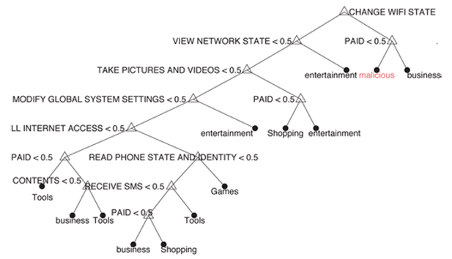
2. They are using an advertising system like AdMob that requires them to use this permission so the 3rd-party advertiser can collect statistics

With our decision tree we were able to come up with a model that successfully differentiated malicious applications from benign applications an average of 96.4 percent of the time. We had hoped to take this data further and find more examples of malicious applications that we could run against this data but were unable to find any more examples of malicious applications to check this against. Unfortunately we were only able to gather the permissions from malicious applications that were developed by only three different people. In order to make our data a little more accurate we ideally would have had access to more known malicious applications that we could have run against our model in order to strengthen it.
Another thing that we noticed over the course of the project was the importance of the System Tools grouping of permissions. This particular grouping contained Change Wi-Fi State, which was one of the most significant indicators of whether or not an application was malicious or not. We represented this with a pair of pie charts, the first of which shows the distribution of permissions for the one hundred and fifty applications that are still on the Android Market and can be seen below.
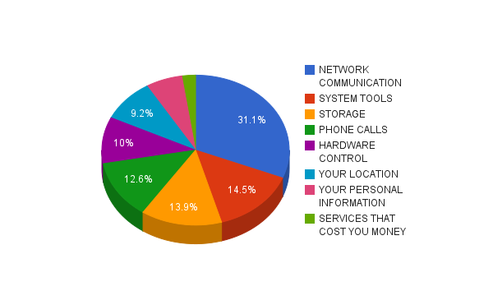
All Benign Apps

The second shows the distribution of permissions for the fifty-six known malicious applications. What we can gain from this graph is the visual distribution for the average application, both good and bad. We can see from the difference in the two graphs what could be indicators of malicious content and what should be expected from the average, non-malicious, applications.
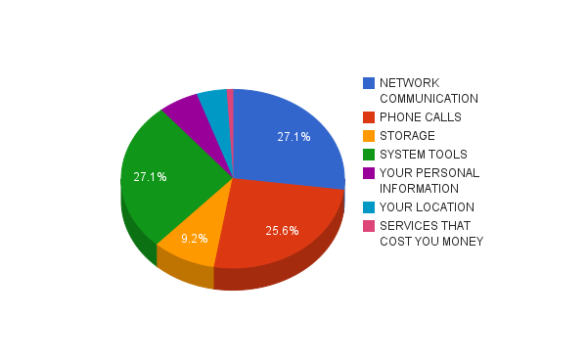
Malicious Apps

Two of the areas where we see the biggest difference are in the use of the phone call permission cluster and the system tools. Other than those two groups of permissions there isn’t much variation in the rest of the clusters of permissions.

Conclusion
The current Android security architecture and system does not adequately provide a secure environment for Android users. Not only did Google have to remove fifty-six malicious applications form its own Android Market, recent studies involving TaintDroid revealed that popular applications are sharing user information with advertisers without informing the user. In addition, the Google provided permission explanations are not adequate in informing an Android user of what they are allowing an application to access. Because of these security concerns, new tools need to be created in order to help inform and educate Android users and protect them from malicious attacks.

With our decision tree, we were able to predict a malicious application 96.4 percent of the time. Our decision tree was able to inform us that a free application requiring Change Wi-Fi State could potentially be malicious if it was combined with certain other permissions. Also, with our research we were able to develop a better understanding regarding the Android mobile platform, the current security architecture, and other possible security risks and concerns. If this decision tree were to be implemented along with other security tools into an Android application, it would help secure an Android user’s personal information as well as prevent malicious attacks. For example, if this decision tree were part of an application that also used the TISSA and TaintDroid frameworks, the application would vastly improve an Android user’s security. The TISSA application would allow for Android user’s to choose what type of information (trusted, bogus, anonymous, or empty) to send to an application dynamically in the areas of location, call log, contact list, and identity. In addition, the TaintDroid framework would inform an Android user if an application has sent the user’s information to an unsupported network or secret node.

To fortify our data results in future work we want to research and identify more malicious developers and applications to run our data against. From this, we would be able to draw comparisons from our data and the new data to create a more robust model and more reliable classifier. Recommendations for future work would include designing an application that would inform users of the possible malicious intent of an application before it was downloaded. We plan on continuing this research with the hopes of one day creating a new security tool that benefits all Android users.

References:
1. Android Market, http://www.android.com/market/
2. Gartner November Report, http://www.gartner.com/it/page.jsp?id=1466313
3. Avik Chaudhuri: Language-Based Security on Android. In: 4th ACM SIGPLAN Workshop on Programming Languages and Analysis for Security. (2009)
4. William Enck, Peter Gilbert, Byung-Gon Chun, Landon P. Cox, Jaeyeon Jung, Patrick McDaniel, Anmol N. Sheth: TaintDroid: An Information-Flow Tracking System for Realtime Privacy Monitoring on Smartphones. In: 9th USENIX Symposium on Operating Systems Design and Implementation. (2010)
5. William Enck, Machigar Ongtang, Patrick McDaniel: On Lightweight Mobile
Phone Application Certiﬁcation. In: 16th ACM Conference on Computer and Com-
munications Security. (2009)
6. William Enck, Machigar Ongtang, Patrick McDaniel: Understanding Android Se-
curity. IEEE Security & Privacy. vol. 7 no. 1. pp. 50–57. (2009)
7. Machigar Ongtang, Stephen E. McLaughlin, William Enck, Patrick Drew Mc-
Daniel: Semantically Rich Application-Centric Security in Android. In: 25th Annual
Computer Security Applications Conference. (2009)
8. Mohammad Nauman, Sohail Khan, Xinwen Zhang: Apex: Extending Android Per-
mission Model and Enforcement with User-Deﬁned Runtime Constraints. In: 5th
ACM Symposium on Information, Computer and Communications Security. (2010)
9. Adam P. Fuchs, Avik Chaudhuri, Jeffrey S. Foster : SCan- Droid: Automated Security Certiﬁcation of Android Applications, http://www.cs.umd.edu/ avik/papers/scandroidascaa.pdf. (2009)
10. Yajin Zhou, Xinwen Zhang, Xuxian Jiang, Vincent Freh: Taming Information-Stealing Smartphone Applications. http://www.csc.ncsu.edu/faculty/jiang/pubs/TRUST11.pdf. (2011)
11. "Around 36% of US mobile customers use smartphones - Telecompaper." TeleCom. 3 May 2011. <http://www.telecompaper.com/news/around-36-of-us-mobile-customers-use-smartphones>.
12. Android Security. (n.d.). MSNBC. Retrieved May 3, 2011, from http://www.msnbc.msn.com/id/41867328/ns/technology_and_science-security/
13. Murph, D. Study: select Android apps sharing data without user notification -- Engadget. Engadget. Retrieved May 3, 2011, from http://www.engadget.com/2010/09/30/study-select-android-apps-sharing-data-without-user-notificatio/
14. Andreas. IDC predicts smartphone statistics. Mobile Mancer. Retrieved May 3, 2011, from http://www.mobilemancer.com/2011/03/31/idc-predicts-smartphone-statistics-for-2015/
15. Android phones now face 70 types of malware, Kaspersky reports | Inside Android. (n.d.). Inside Android. Retrieved May 3, 2011, from http://www.inside-android.com/news-android-phones/android-phones-now-face-70-types-of-malware-kaspersky-reports/
16. Ponemon Institute Survey on Smartphone Security. http://aa-download.avg.com/filedir/other/Smartphone.pdf
17. Google Android: A State-of-the-Art Review of Security Mechanisms.
http://arxiv.org/abs/0912.5101

